FUNCTION PRACTICE

1. Write a Python function to find the maximum of three numbers.

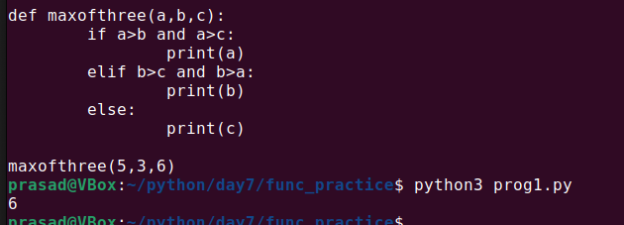

2. Write a Python function to sum all the numbers in a list.

Sample List : (8, 2, 3, 0, 7)

Expected Output : 20

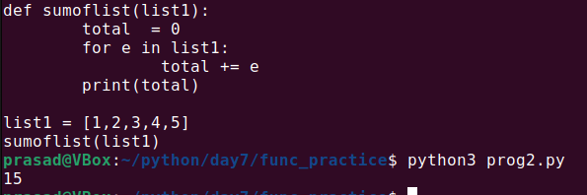

3. Write a Python function to multiply all the numbers in a list.

Sample List : (8, 2, 3, -1, 7)

Expected Output : -336

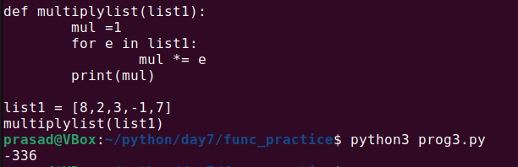

4. Write a Python program to reverse a string.

Sample String : "1234abcd"

Expected Output : "dcba4321"

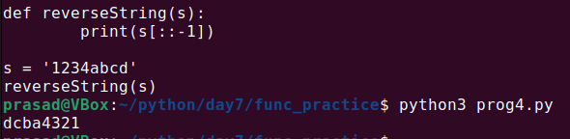

5. Write a Python function to calculate the factorial of a number (a non-negative integer). The function accepts the number as an argument.

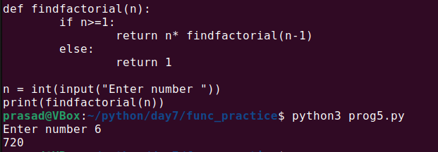

6. Write a Python function to check whether a number falls within a given range.

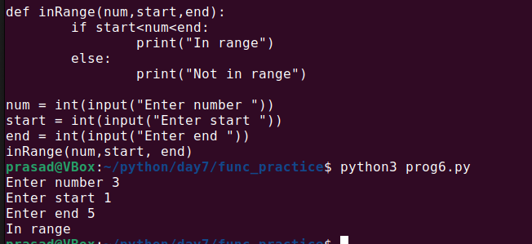

7. Write a Python function that accepts a string and counts the number of upper and lower case letters.

Sample String : 'The quick Brow Fox'

Expected Output :

No. of Upper case characters : 3

No. of Lower case Characters : 12

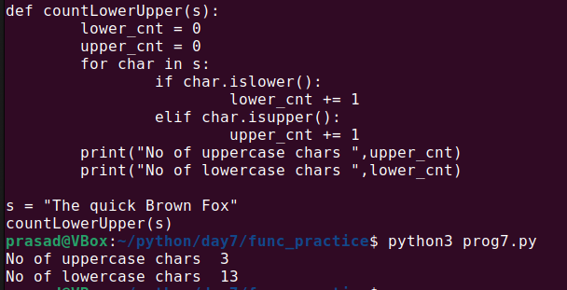

8. Write a Python function that takes a list and returns a new list with distinct elements from the first list.

Sample List : [1,2,3,3,3,3,4,5]

Unique List : [1, 2, 3, 4, 5]

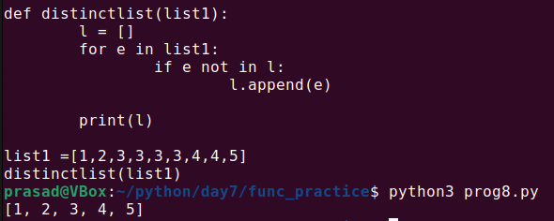

9. Write a Python function that takes a number as a parameter and checks whether the number is prime or not.

Note : A prime number (or a prime) is a natural number greater than 1 and that has no positive divisors other than 1 and itself.

10. Write a Python program to print the even numbers from a given list.

Sample List : [1, 2, 3, 4, 5, 6, 7, 8, 9]

Expected Result : [2, 4, 6, 8]

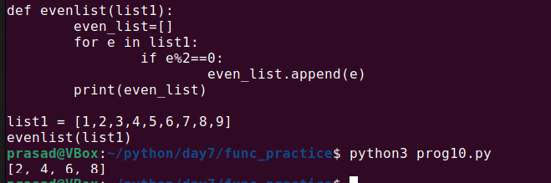

11. Write a Python function to check whether a number is "Perfect" or not.

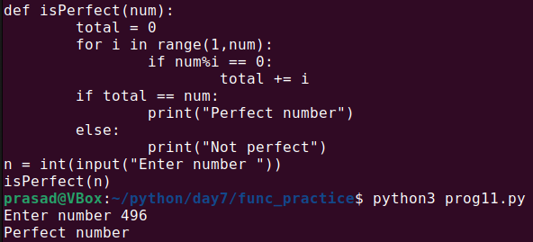

12. Write a Python function that checks whether a passed string is a palindrome or not.

Note: A palindrome is a word, phrase, or sequence that reads the same backward as forward, e.g., madam or nurses run.

13. Write a Python function that prints out the first n rows of Pascal's triangle.

Note : Pascal's triangle is an arithmetic and geometric figure first imagined by Blaise Pascal.

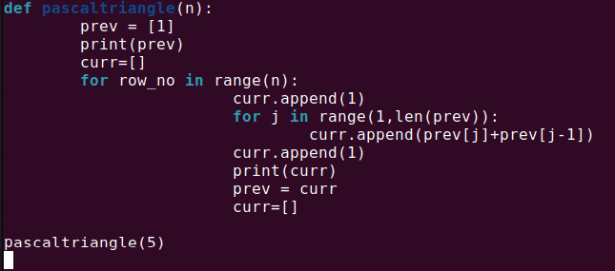

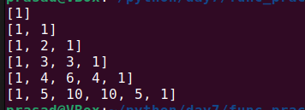

14. Write a Python function to check whether a string is a pangram or not.

Note : Pangrams are words or sentences containing every letter of the alphabet at least once.

For example : "The quick brown fox jumps over the lazy dog"

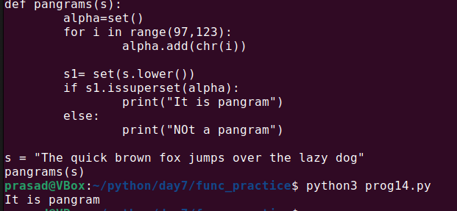

15. Write a Python program that accepts a hyphen-separated sequence of words as input and prints the words in a hyphen-separated sequence after sorting them alphabetically.

Sample Items : green-red-yellow-black-white

Expected Result : black-green-red-white-yellow

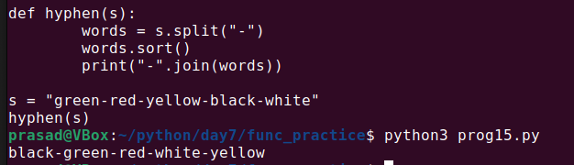

16. Write a Python function to create and print a list where the values are the squares of numbers between 1 and 30 (both included).

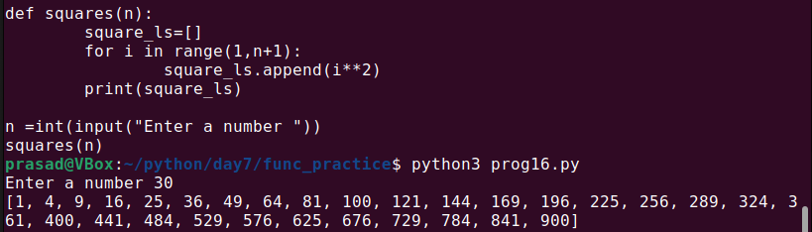

17. Write a Python program to create a chain of function decorators (bold, italic, underline etc.).

18. Write a Python program to execute a string containing Python code.

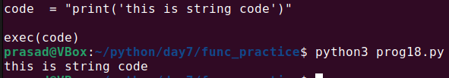

19. Write a Python program to access a function inside a function.

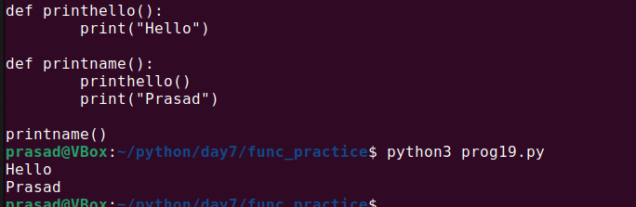

20. Write a Python program to detect the number of local variables declared in a function.

Sample Output: 3

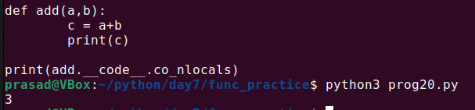

21. Write a Python program that invokes a function after a specified period of time.

Sample Output:

Square root after specific miliseconds:

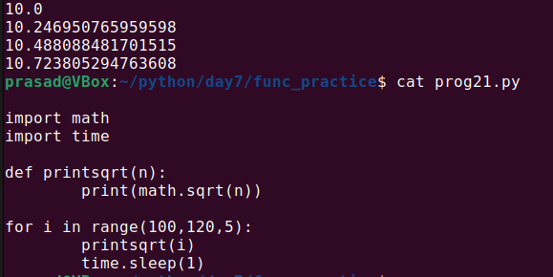

LAMBDA FUNCTIONS

Lambda Functions ::::

1. Write a Python program to create a lambda function that adds 15 to a given number passed in as an argument, also create a lambda function that multiplies argument x with argument y and prints the result.

Sample Output:

25

48

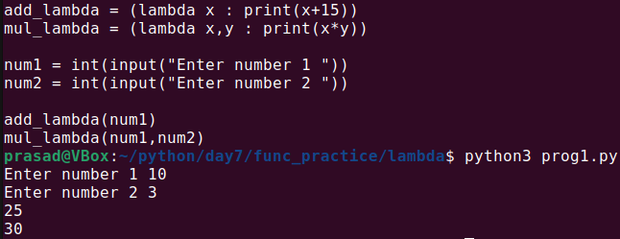

2. Write a Python program to create a function that takes one argument, and that argument will be multiplied with an unknown given number.

Sample Output:

Double the number of 15 = 30

Triple the number of 15 = 45

Quadruple the number of 15 = 60

Quintuple the number 15 = 75

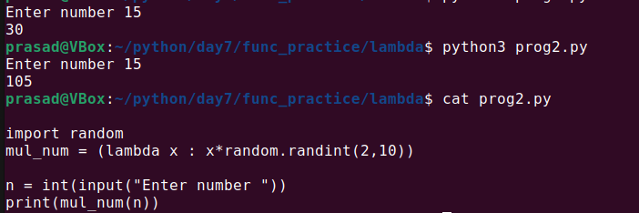

3. Write a Python program to sort a list of tuples using Lambda.

Original list of tuples:

[('English', 88), ('Science', 90), ('Maths', 97), ('Social sciences', 82)]

Sorting the List of Tuples:

[('Social sciences', 82), ('English', 88), ('Science', 90), ('Maths', 97)]

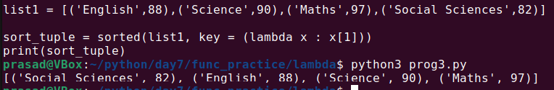

4. Write a Python program to sort a list of dictionaries on color using Lambda.

Original list of dictionaries :

[{'make': 'Nokia', 'model': 216, 'color': 'Black'}, {'make': 'Mi Max', 'model': '2', 'color': 'Gold'}, {'make': 'Samsung', 'model': 7, 'color': 'Blue'}]

Sorting the List of dictionaries :

[{'make': 'Nokia', 'model': 216, 'color': 'Black'}, {'make': 'Samsung', 'model': 7, 'color': 'Blue'}, {'make': 'Mi Max', 'model': '2', 'color': 'Gold'}]

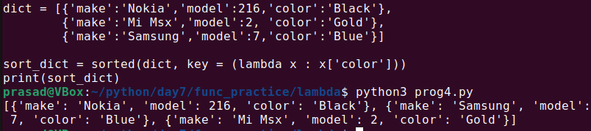

5. Write a Python program to filter a list of integers using Lambda.

Original list of integers:

[1, 2, 3, 4, 5, 6, 7, 8, 9, 10]

Even numbers from the said list:

[2, 4, 6, 8, 10]

Odd numbers from the said list:

[1, 3, 5, 7, 9]

6. Write a Python program to square and cube every number in a given list of integers using Lambda.

Original list of integers:

[1, 2, 3, 4, 5, 6, 7, 8, 9, 10]

Square every number of the said list:

[1, 4, 9, 16, 25, 36, 49, 64, 81, 100]

Cube every number of the said list:

[1, 8, 27, 64, 125, 216, 343, 512, 729, 1000]

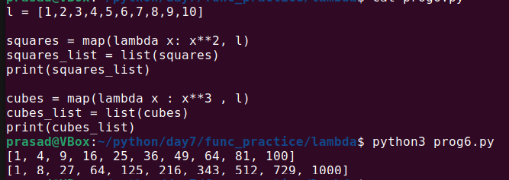

7. Write a Python program to find if a given string starts with a given character using Lambda.

Sample Output:

True

False

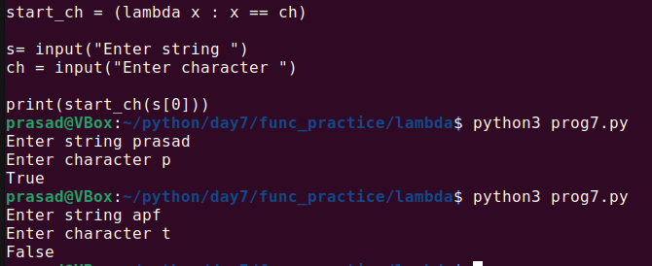

8. Write a Python program to extract year, month, date and time using Lambda.

Sample Output:

2020-01-15 09:03:32.744178

2020

1

15

09:03:32.744178

9. Write a Python program to check whether a given string is a number or not using Lambda.

Sample Output:

True

True

False

True

False

True

Print checking numbers:

True

True

10. Write a Python program to create Fibonacci series up to n using Lambda.

Fibonacci series upto 2:

[0, 1]

Fibonacci series upto 5:

[0, 1, 1, 2, 3]

Fibonacci series upto 6:

[0, 1, 1, 2, 3, 5]

Fibonacci series upto 9:

[0, 1, 1, 2, 3, 5, 8, 13, 21]